
UF Bergstrom Real Estate Center
WHITE PAPER SERIES
February 2026
№1

Beyond the Three Approaches:
How Valuation Support Indicators Can Strengthen Commercial Real Estate Appraisals in Volatile Markets
Author: Jeffrey D. Fisher, Ph.D.

Beyond the Three Approaches: How Valuation Support Indicators Can Strengthen CRE Appraisals in Volatile Markets

Jeffrey D. Fisher, Ph.D.*

I. Abstract
The traditional real estate appraisal process, while foundational, faces significant challenges and opportunities in today's dynamic and data-rich commercial real estate (CRE) markets. The three established approaches—cost, sales comparison, and income—has notable limitations, particularly during periods of market volatility. This report examines potential areas for reform: the suitability of current value definitions, the methodological constraints inherent in traditional approaches, and the imperative for upholding process integrity. It advocates for Valuation Support Indicators (VSIs) that inform the reconciliation of value indications from the three traditional approaches by providing market-based rationale for selecting a value within the range suggested by each approach. VSIs capture market liquidity conditions such as the gap between private market cap rates and implied public market cap rates, below average transactions volume, wider than average bid ask spreads and longer than normal marketing time. Additionally, divergence between values produced by automated valuation models (AVMs), artificial intelligence (AI), or machine learning (ML) and the traditional approaches can serve as a fifth VSI—providing additional market signals to inform value selection.
The VSIs could be used to justify putting more weight on the result of one of the three traditional approaches to estimating value or used to help select the value indication within an approach—such as placing greater reliance on a lower price per unit of comparison or a higher cap rate when indicated by the VSIs. This framework should enhance the accuracy, timeliness, and transparency of commercial real estate valuations, making them more relevant and reliable for diverse stakeholders.

*Jeffrey D. Fisher is Professor Emeritus at Indiana University and Visiting Professor at Johns Hopkins University. He is also President of the Homer Hoyt Institute and Consulting Director of Research and Education for the National Council of Real Estate Investment Fiduciaries (NCREIF). He is a member of the Real Estate Counseling Group of America (RECGA) and was a founding trustee of The Appraisal Foundation. All views expressed in this paper are only the opinion of Dr. Fisher.
II. Introduction: The Imperative for Appraisal Reform in Commercial Real Estate

Appraisals remain a critical component of real estate price discovery, providing essential valuations for a myriad of purposes, including lending, property taxation, eminent domain, financial reporting, and investment performance measurement. However, the infrequent trading of properties means that reliance on past transaction prices is often insufficient for timely valuation as compared to public markets that might have multiple transactions of an interest in securitized real estate daily. The depreciated replacement cost of the asset can differ significantly from its value when new construction is not feasible and forecasting future cash flows can also be problematic. Thus, the profession's traditional framework, which relies on the cost, sales comparison, and income methods, performs adequately in stable market conditions, but may be inadequate in dynamic markets.
The limitations of the three conventional methods become acutely apparent during sudden and significant market shifts, such as those witnessed during the COVID-19 pandemic and subsequent periods of monetary tightening. In a weakening market, sellers tend to remain anchored to recently achieved prices while buyers are more likely to incorporate new risk perceptions and tighter financing conditions into their bids. The transactions that would clear at true equilibrium prices don't occur because neither party accepts the other's valuation. Appraisers haven’t traditionally incorporated evidence about bid – ask spreads and disparities with pricing in the public market into the appraisal process. This can cause appraisers to systematically overstate what a property would fetch in the market.

Several articles from market participants and professional organizations written during recent years of market turmoil have been very critical of the appraisal process. Green Street in a Quick Take: Informational article October 29, 2025 stated: “During times of stress, private pricing suffers from appraisal lag. As normalcy returns to the transaction market it dissipates.”¹ A Prologis Research article titled “A Valuation Lag too significant to Ignore”² and an article by NAREIT entitled “Wearing Blinders: Some CRE Appraisals Continue to Ignore Capital Market Realities”³ also address issues.
There is clearly a perception from several observers that appraised values differ from what they think the properties are worth based on their observation of factors such as bid and ask prices that may not result in transactions.
This also causes concern about whether price indices that are based on these appraised values are best capturing market conditions. Research by David Geltner and others has documented this effect extensively—NCREIF appraisal-based returns exhibit smoothing and lag transaction-based measures by roughly 2-4 quarters during market turns.²⁷

This suggests the need for Valuation Support Indicators (VSIs) that can inform the selection of a value within the range suggested by each of the three established approaches when market conditions warrant—along with a better understanding of why these pricing differences exist and what value should be reflected in an appraisal. This report delves into three pivotal areas requiring reform within commercial real estate appraisal: (1) the suitability of existing value definitions, (2) the methodological constraints that limit the effectiveness of traditional approaches, and (3) the critical importance of process integrity. The discussion will propose the integration of public market indicators, such as Real Estate Investment Trust (REIT) pricing data and sentiment indices, alongside advanced analytical tools, including automated valuation models (AVMs) and machine learning, as a path toward improving appraisal accuracy, timeliness, and transparency. We propose VSIs that would inform the reconciliation of value indications from the three traditional approaches (cost, sales comparison, and income) when the market exhibits unusually low liquidity. The VSIs could be used to justify putting more weight on the result of one of the three traditional approaches to estimating value or used to help select the value indication within an approach—such as placing greater reliance on a lower price per unit of comparison or a higher cap rate when indicated by the VSIs. This framework should enhance the accuracy, timeliness, and transparency of commercial real estate valuations, making them more relevant and reliable for diverse stakeholders.
The VSIs include: 1) disparities between public and private market pricing, 2) longer than average marketing time, 3) wider than average bid-ask spreads, and 4) lower than average transaction volume. Additionally, divergence between values produced by automated valuation models (AVMs), artificial intelligence (AI), or machine learning (ML) and the traditional approaches can serve as a fifth VSI.

III. What Value?

The first question is “what value” are appraisers estimating? The valuation of real estate assets typically navigates between distinct definitions of value, each serving a particular purpose. Market Value, as defined by the Appraisal Institute, represents the "most probable price" that a property would command under competitive, open-market conditions on the appraisal date. This definition assumes a willing buyer and seller, reasonable market exposure, and a transaction free from compulsion, prioritizing observable market conditions over theoretical equilibrium prices. Its primary applications include lending, taxation, and transactional purposes.

3.1. Fair Value
Fair Value, under International Financial Reporting Standards (IFRS, 2011), is articulated as "the price that would be received to sell an asset…in an orderly transaction between market participants at the measurement date".⁴ While conceptually similar to Market Value, Fair Value places greater emphasis on the "orderly" nature of the transaction. Fair Value is predominantly utilized for financial reporting. This is usually considered to mean that a forced liquidation or a distressed sale should be excluded from the analysis but does not mean that fair value ignores distressed market conditions. One subtle difference that can make a difference in distressed markets is that market value assumes that the property has already been exposed to the market for a reasonable period of time whereas fair value does not make this assumption. The question of whether fair value inherently discounts for time to sell the property relative to Market Value could result in a difference in value. Especially during down markets when discounting for the longer time to market could result in a somewhat lower value. Fair Value also sometimes considers a portfolio of properties being the “unit of account” and reflect how that impacts value. The Market Value of a portfolio is usually the aggregate of individual estimated property values. These subtle differences between Market Value and Fair Value could result in differences during periods like the U.S. financial crisis of 2008 or during the COVI-19 pandemic. But both types of value tend to rely on the same three approaches and suffer from the same limitations. In practice, Market Value and Fair value are usually considered synonymous and institutional investors use market value for financial reporting.

3.2. The Role of Investment Value in Institutional Contexts
Beyond Market Value and Fair Value, it is sometimes argued that "Investment Value" is what should be reported by institutional investors. Investment Value is unique to a specific fund or investor, and it can significantly deviate from Market Value. It incorporates a range of investor-specific assumptions, including their cash flow projections, tax rates, financing capabilities, perceived business strengths, the impact of the property investors’ overall investment and risk strategy, and their specific target rates of return and perceived level of risk in the investment.
A notable conflict arises in fund reporting: while arguments are sometimes made about valuing a fund's properties based on their Investment Value to reflect their worth to a particular investment manager or investor, regulatory requirements typically mandate reporting based on Market Value. Performance reporting standards also frequently require Market Value. The investment value to a manager of an asset might exceed what the property can be sold for in a weak market; however, the Market Value is required for external financial transparency.
While not appropriate for financial reporting, it should be noted that since Investment Value is specific to an investor, it doesn’t have to rely on the traditional approaches to value as usually considered necessary to estimate Market Value. Thus, some of the approaches to valuation suggested later in this paper can be used to estimate Investment Value.

Table 1: Commercial Real Estate Value Definitions: Divergence and Application

Value Type | Definition | Primary Application | Divergence in Volatile Markets
Market Value | The most probable price a property would sell for under competitive, open-market conditions. | Lending, property taxation, transactional purposes. | Can diverge significantly from long-term economic value in distressed or illiquid markets; susceptible to rapid shifts due to interest rate changes and forced sales. Assumes the property has already been exposed to the market as of the date of the appraisal.
Fair Value | The price that would be received to sell an asset in an orderly transaction between market participants. | Financial reporting (IFRS). | Emphasizes "orderly transactions," which may not exist in distressed markets. Does not assume property has already been exposed to the market.
Investment Value | The value to a particular investor or fund, based on their unique investment objectives, business plan, and assumptions. | Internal investment decision-making, strategic acquisitions, portfolio performance measurement from an investor's perspective. | May differ markedly from Market Value, , as investors may have different NOI forecasts, target yields, risk perceptions and tolerance, or long-term value-add strategies.

IV. Methodological Constraints
The traditional three-approach appraisal method, while foundational, is increasingly insufficient in volatile, data-rich markets. Its methodological constraints, particularly the independence of approaches, can be compromised in practice.

4.1. Limitations of Traditional Approaches in Dynamic Commercial Markets
The traditional appraisal approaches—cost, sales comparison, and income – are all used when there is sufficient data. There are limitations to each that can result in one or more of the approaches being less reliable.

4.1.1. Sales Comparison Approach: Challenges in Data Availability and Subjectivity of Adjustments
The sales comparison approach is predicated on analyzing recent sales of similar properties and adjusting their prices to account for differences from the subject property.⁵ However, a fundamental challenge lies in the difficulty of finding truly comparable properties, especially in markets characterized by high property diversity. This method's reliance on recent sales data means it may not accurately reflect rapid changes that have occurred in the market since the date of the comparable property. When recent comparable sales are scarce, appraisers may be forced to rely on older data or information from less relevant geographic areas, which can lead to valuations that do not accurately reflect current market conditions. A large number of truly comparable properties are rarely available for commercial real estate as opposed to residential properties with lots of similar home sales.
The increasing specialization and unique functional requirements of modern commercial properties may undermine the "comparable" premise of this approach. For instance, finding direct comparables for highly specialized commercial assets like purpose-built data centers, advanced cold storage facilities, or manufacturing plants with highly customized layouts is exceptionally difficult. Similarly, properties with significant Environmental, Social, and Governance (ESG) certifications, which are increasingly influencing capital allocation, may lack sufficient comparable sales to accurately quantify their value premium.⁶ This scarcity forces appraisers to broaden their search criteria or use older data, necessitating more subjective and potentially less reliable price adjustments in dynamic or niche markets. The blurring of real estate value with business enterprise value for properties such as hotels further complicates direct comparisons, as the transaction price often includes intangible business assets that are not easily separable from the physical real estate.⁶ This makes the approach less reliable in rapidly evolving or niche commercial markets where true substitutes are scarce.
Furthermore, the adjustments made to comparable sales prices to account for differences are, in the absence of regression models (AVMs), inherently subjective. These adjustments encompass a wide range of factors, including physical attributes (e.g., square footage, layout, ceiling height), location-specific elements (e.g., access, visibility, market position), economic characteristics (e.g., tenant mix, lease terms), and property condition. The qualitative and complex nature of many commercial property attributes, especially in dynamic markets, renders subjective adjustments highly susceptible to appraiser judgment and potential bias. Different analysts might arrive at varying adjustment decisions even when presented with the same data. For example, quantifying the market's reaction to a commercial property's specific tenant credit quality, the sophistication of its building systems, or its potential for future improvements is far more complex and open to interpretation than making adjustments for simpler residential property features like the number of bathrooms or the presence of a garage. Unsupported or arbitrary adjustments can significantly undermine the credibility of the appraisal, leading to substantial variations and inaccuracies in valuations, particularly when market conditions are in flux and clear market-derived adjustments are less evident.
We should not treat listings of properties as if they were indicative of the most likely sale price since they only represent a “ask” price and if completed, the transaction price could be lower (although in some markets it could be higher). However, bid prices do provide some market information and can help in determining the most likely direction of the market. AVMs, discussed later, and other machine learning models can adjust for the difference between the list price and a most likely sale price and can be used in the process of estimating value. Furthermore, a wide bid ask spread could suggest a need for an adjustment to the market value estimated from the traditional three approaches – especially in a down market.

4.1.2. Income Approach: Forecasting Challenges Amidst NOI and Cap Rate Volatility
The income approach tends to be used in two somewhat distinct ways. Income Capitalization is usually done using discounted cash flow analysis which estimates a property's value based on its income-generating potential. However, its accuracy hinges on the reliability of its core inputs such as the Net Operating Income (NOI) from existing leases and lease renewals, capital expenditures, discount rates and terminal capitalization rates (cap rates). This method requires extensive data and assumptions, and its ability to accurately capture market value is compromised if projected income streams are inconsistent or unreliable. Forecasting cash flows for typical commercial property holding periods, often 5-10 years, is inherently complex, and any forecasting errors in the initial years tend to compound significantly over the projection period. Common pitfalls include inaccurate NOI calculations, insufficient market analysis, and inadequate risk assessment to determine an appropriate discount rate.
The second way that the income approach is applied is Direct Capitalization which mainly relies on ratios such as potential gross income multipliers and capitalization rates, which are the ratio first-year of net operating income to value. Capitalization rates are often obtained by observing the ratio of projected first-year NOI to the transaction price of similar (comparable) properties. This is similar to the sales-comparison approach and implicitly reflects the factors that really determine value such as the future NOI and other factors such as those used in a DCF analysis. In fact, implied cap rates are often calculated by dividing the current Net Operating Income for a property by its value that was derived from a DCF analysis. These cap rates can then be compared with those obtained from market transactions as a check on value. Thus, although cap rates themselves don’t “determine” value, they are often used as an indicator of how investors are pricing real estate.
Using the income approach can also be a challenge since rapid market changes directly impact on the reliability of Net Operating Income (NOI) forecasts. For example, the COVID-19 pandemic led to a sharp drop in both operating revenues and the overall demand for commercial real estate, resulting in widespread empty office buildings, reduced store hours, [and] unbelievably low hotel room rates. The widespread adoption of work-from-home policies caused national office vacancy rates to climb to a record high of 20.4% in Q1 2025 as a result of a significant reduction in demand for office space and negative net absorption.⁷ Similarly, the rise of e-commerce negatively impacted retail NOIs by reducing demand for physical storefronts, while simultaneously boosting industrial (warehouse/logistics) NOI due to increased demand for distribution space. Such rapid and differential shifts across property types render historical NOI data less predictive and future forecasting highly uncertain, as the fundamental drivers of a property's income-generating potential are rapidly and fundamentally altered.
Discount rates and cap rates are also highly sensitive to external economic factors, including interest rates, Gross Domestic Product (GDP), and unemployment. Rising interest rates, a characteristic of monetary tightening, can lead to upward pressure on discount rates, which inversely affects property values and results in higher cap rates (NOI / Value). In periods of market stress, such as the Great Financial Crisis, cap rates have been observed to increase even when interest rates decreased, reflecting a higher perceived investment risk by market participants. The high sensitivity of cap rates to macroeconomic conditions and investor risk perception means that during volatile periods, even minor misjudgments in forecasting cap rate movements can lead to substantial errors in commercial property valuations. This highlights a critical vulnerability of the income approach, as it relies on forward-looking projections that are inherently difficult to predict in uncertain markets.

4.1.3. Cost Approach: Applicability and Depreciation in Rapidly Changing Markets
The cost approach estimates a property's value by considering the current cost to replace or reproduce it, minus any accrued depreciation.⁸ While this method is particularly useful for new or unique properties where comparable sales data may be scarce, it may not accurately reflect market value if the cost of construction does not align with prevailing demand or buyer preferences. Accurately determining both the replacement cost and assessing accrued depreciation, which encompasses physical deterioration, functional obsolescence, and external obsolescence—are critical yet complex steps in this approach.
The accuracy of the cost approach is highly dependent on precise estimates of current construction costs, including materials and labor. However, these inputs can fluctuate rapidly due to global supply chain disruptions (e.g., those experienced post-pandemic), inflationary pressures, and evolving trade policies like tariffs. This volatility makes it challenging for appraisers to maintain up-to-date cost data, leading to replacement cost estimates that can quickly become outdated and unreliable, particularly for large, complex commercial projects. This means that in rapidly changing markets, the estimated "replacement cost" may not reflect current market realities or investor willingness to pay, especially for older properties. Functional and external obsolescence present particularly pronounced challenges for commercial properties in dynamic markets. Functional obsolescence, which refers to issues with a property's design or layout, is typically evident in older office buildings whose layouts may not support modern flexible work arrangements or which lack amenities now desired by tenants. External obsolescence, stemming from factors outside the property's boundaries, can arise from significant market shifts such as the permanent decline in demand for traditional retail due to the rise of e-commerce or changes in a neighborhood's economic vitality. Furthermore, the potential "blurring of business value” (going concern elements of valuation) and the pure real estate fee-simple property rights complicates the cost approach for properties like self-storage facilities or hotels. In these cases, intangible business assets are intrinsically intertwined with physical costs, making it difficult to isolate and accurately depreciate only the real estate component. The rapid evolution of commercial property uses, and tenant preferences accelerates the rate of functional and external obsolescence, rendering the traditional cost approach less effective at capturing a property's true market value. This necessitates a more sophisticated and dynamic assessment of depreciation that accounts for changing market demands and the intertwined nature of real estate and business value.
4.1.4. Independence of the Three Approaches
The three approaches might have been theoretically designed to function independently, providing distinct avenues to value estimation. However, practical applications sometimes compromise this independence. In fact, USPAP requires the appraiser to reconcile the three approaches to a final value estimate. Many appraisers believe that the three traditional approaches are intentionally interrelated and not intended to be independent. But that means that the final value may in actuality only be the result of a single approach. E.g., the depreciation in the cost approach might be derived from the difference between the undepreciated replacement cost and the results from the income approach. This reduces the overall robustness of the reconciliation process. While these methods perform adequately in stable market conditions, their inherent limitations become pronounced during periods of sudden market shifts. To be checks on one another, they should be as independent as possible with the final reconciliation process designed to understand why there are differences in the values that they suggest. This might also suggest that the additional approaches to be discussed that are truly independent would better serve the user of the appraisal.

Table 2: Challenges and Solutions for Traditional Appraisal Approaches in Commercial Real Estate

Approach | Challenge | Impact | Proposed Solution
Sales Comparison | Difficulty finding truly comparable commercial properties, especially in weak markets with infrequent transactions and for unique or specialized assets (e.g., data centers, green buildings). High subjectivity in adjustments for qualitative factors (e.g., tenant credit quality, specific lease terms) in volatile markets. | Leads to inaccuracies, reduced credibility, and unreliable valuations, particularly in rapidly shifting or niche markets. | Augment with public market indicators (REITs, sentiment indices) for broader market context, leading signals, and dynamic cap rate insights. Integrate AVMs and Machine Learning for enhanced pattern recognition, data synthesis, and objective comparisons across larger datasets.
Income | Significant volatility in forecasting Net Operating Income (NOI) due to rapid market shifts (e.g., work-from-home impact on office demand, e-commerce impact on retail/industrial). High sensitivity and volatility of capitalization rates (cap rates) to macroeconomic factors (e.g., interest rates, GDP, unemployment) and perceived risk. | Compounding forecasting errors over multi-year holding periods, leading to substantial inaccuracies in commercial property valuations. | Utilize real-time public market data (REITs, sentiment indices) for dynamic cap rate and income trend insights, providing more responsive inputs. Employ predictive analytics and Machine Learning for more robust, non-linear forecasting models that can adapt to changing market dynamics and process diverse data streams.
Cost | Rapid and unpredictable fluctuations in construction costs (materials, labor) due to supply chain issues, inflation, and tariffs. Complexity in accurately assessing functional and external obsolescence for evolving commercial property types. Difficulty in distinguishing and depreciating the real estate component from integrated business value (going concern) for specialized assets. | Leads to outdated replacement cost estimates, miscalculation of depreciation, and potential misevaluation of commercial properties, especially older or specialized assets. | Leverage granular data and Machine Learning to better estimate dynamic construction costs and identify nuanced depreciation factors. Emphasize clear methodological frameworks to distinguish between real estate and business value components, as advocated by industry bodies.

V. Expanding the Approaches

5.1. Leveraging Public Market Indicators for Enhanced Timeliness and Accuracy
To overcome the potential lags and limitations of traditional appraisal methods, integrating public market indicators can play a role enhancing the timeliness and accuracy of commercial real estate valuations. Publicly traded Real Estate Investment Trusts (REITs) offer a potential mechanism for gaining timely insights into commercial real estate market dynamics. Listed REIT share prices, which reflect aggregated investor sentiment, adjust rapidly to new information, such as changes in interest rates, macroeconomic indicators, or underlying property market fundamentals. This inherent speed stands in stark contrast to the significant lag observed in private real estate valuations, which are typically tied to slower-moving appraisal and transaction cycles. Empirical evidence consistently demonstrates that REITs react quickly to new information, which may allow them to serve as a leading indicator for private commercial real estate performance while recognizing that there can be randomness and false signals as well.¹ The divergence between public and private real estate cap rates is illustrated in the following graph that compares Nareit implied publicly traded REIT cap rates with private market cap rates from NCREIF. The NCREIF cap rates are for properties in funds that are in the NCREIF ODCE (open end diversified equity) index. The data are from a period when markets were still recovering from highs reached pre-COVID.
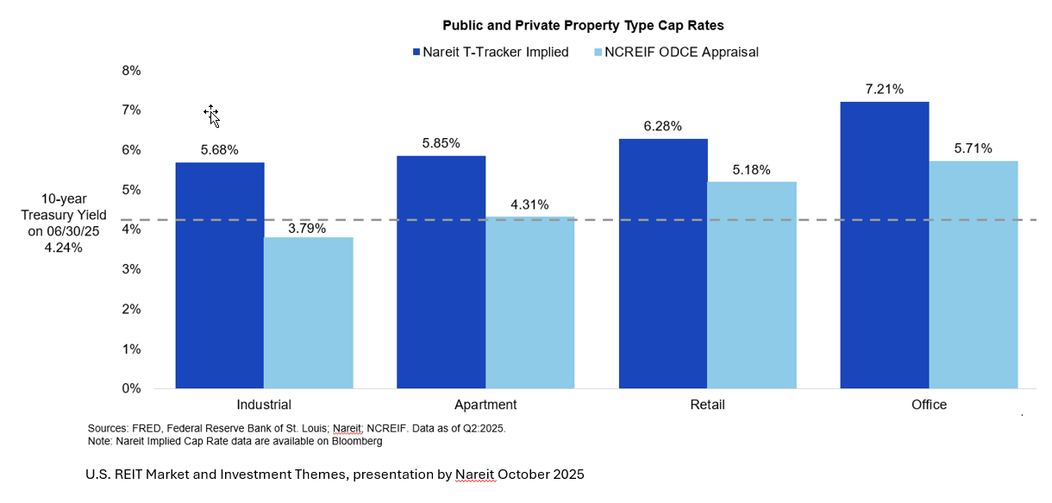
The cap rates diverged significantly immediately after COVID although the gap has started to narrow as the market recovers. In fact, the cap rates based on actual sales of properties from the ODCE index (NCREIF ODCE Transaction cap rates) did converge with the Nareit REIT implied cap rates.
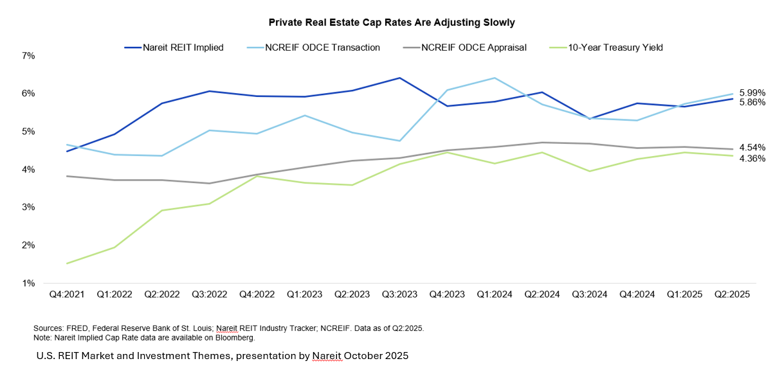
Green Street's Commercial Property Price Index (CPPI), which is based on frequently updated estimates of price appreciation of property portfolios owned by REITs, shows similar differences in the performance of public vs. private real estate.⁹ Whether REITs captured the true price movements during this period can be debated, but this suggests that the answer might be somewhere between the two.
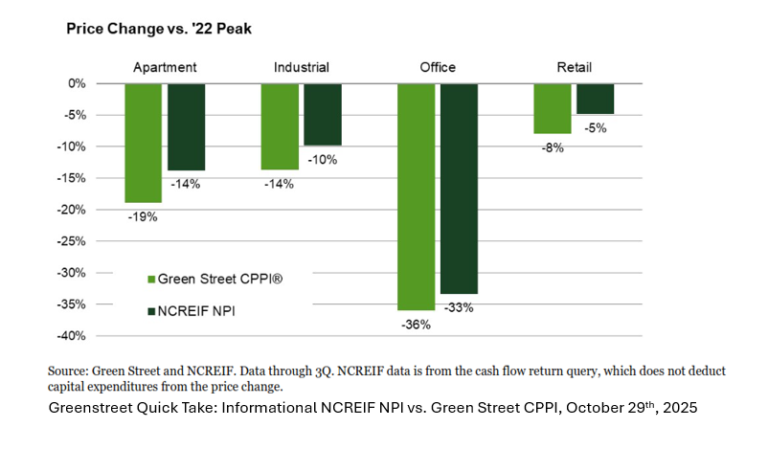
REIT-implied cap rates would seem to be important in providing timely market signals even if not relied upon completely for reasons to be discussed. REITs reflects changes in commercial property values "as soon as we hear about them" because it does not have to wait for deals to close, unlike other indices that rely on closed transactions or formal appraisals that may reflect market prices from many months earlier. The inherent liquidity and real-time pricing mechanism of publicly traded REITs thus provide a dynamic, forward-looking proxy for investor expectations and market conditions in commercial real estate. This offers appraisers a critical, timely signal that can significantly reduce the inherent lag and smoothing bias observed in traditional private market appraisals, thereby enhancing the relevance and responsiveness of valuations in volatile markets.
At the same time, public markets reflect “consensus market forecast” based on how the most recent news events and other market signals are expected to impact future income, discount rates, etc. The forecast may not always be correct. Private real estate also trades in a different market than public real estate, which is less liquid and may not have the same investors that determine prices at the margin. So, some differences in prices might be expected although investors would be expected to take advantage of any significant price gaps. The challenge for the appraiser is to use judgment to determine if public market information provides useful information to help reconcile the estimate of value due to a shift in market fundamentals not being captured in current private market transactions, or if it is more likely to be noise contained in the public markets.
The following chart compares the cumulative return of private real estate funds (ODCE Gross Fund Return) and REITs based on the NAREIT index. By the time the market recovered in 2012, the cumulative return for both were the same over the 5 years. But REITs in the public market declined further and recovered more to catch up. Are public markets reflecting the true changes in market value or could they have overreacted? Furthermore, REIT returns may reflect more than just the underlying real estate. When investors buy REIT shares, they're purchasing equity in a company that owns real estate, not the properties directly. The share price incorporates factors such as how much debt the REIT carries—higher leverage amplifies both losses and gains relative to the underlying property values. Additionally, the market prices in its assessment of management's track record and capabilities in areas like acquisitions, operations, and capital allocation. Finally, daily trading in public markets introduces liquidity and sentiment-driven volatility that doesn't exist in the appraisal-based valuations of private real estate funds. The point is that this is an additional source of information that can be used in the appraisal process.
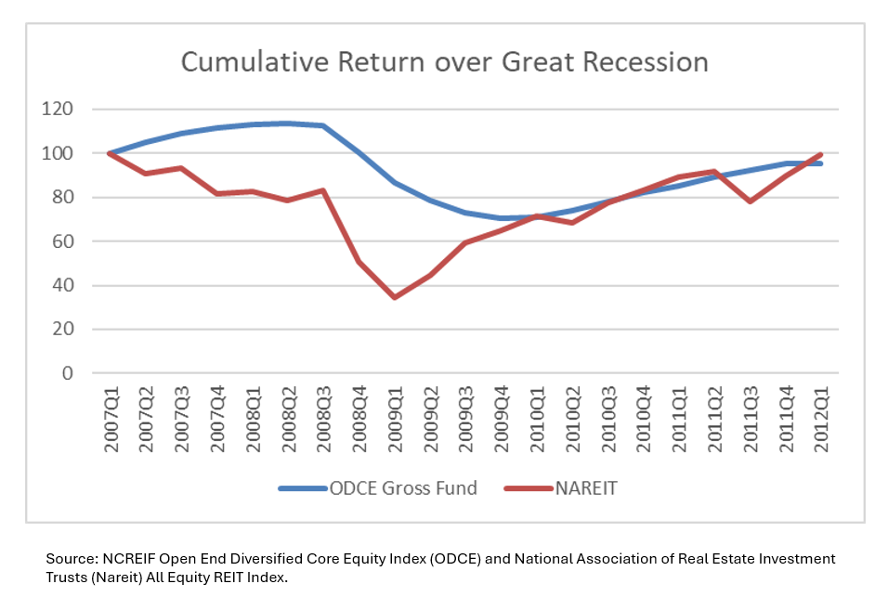
This is not to suggest that REIT implied prices provide the best indication of the value of private equity real estate. Rather, it is suggested that this can be incorporated into the thought process more formally than it has traditionally been and included as part of the reconciliation process in arriving at a final value estimate.

5.2. The Value of Commercial Property Sentiment Indices
Commercial property sentiment indices provide another valuable layer of forward-looking market intelligence. In the UK, the Royal Institution of Chartered Surveyors (RICS) Commercial Property Market Survey is widely utilized to monitor market turning points. These indices track forward-looking measures such as occupier demand trends, investment inquiries, and anticipated rental growth. Similarly, the NAIOP CRE Sentiment Index is specifically designed to predict general conditions in the commercial real estate industry over the subsequent 12 months, surveying professionals on their expectations for jobs, space markets, construction costs, and capital markets.¹⁰ The NAIOP survey is conducted biannually, distributed to approximately 10,000 NAIOP members including developers, building owners, brokers, analysts, consultants, lenders, and investors. Questions are weighed based on consistency of responses, with scores ranging from 0 (most pessimistic) to 100 (most optimistic).
These indices offer appraisers early signals of cyclical inflection points. They can indicate expectations for more favorable conditions, such as higher face rents, lower construction labor costs, or lower cap rates. By systematically capturing the collective forward-looking sentiment of commercial real estate professionals, these indices offer a valuable, albeit qualitative, leading indicator of market direction. This enables appraisers to anticipate shifts in demand, supply, and pricing, allowing for more proactive adjustments to valuation assumptions and reducing over-reliance on lagging transaction data.

5.3. Integrating Advanced Analytical Tools for Modern Commercial Appraisal
The modernization of commercial real estate appraisal necessitates the integration of advanced analytical tools, including automated valuation models (AVMs) and machine learning, to significantly enhance accuracy, timeliness, and transparency.

5.3.1. Automated Valuation Models (AVMs) and Predictive Analytics: Benefits and Applications
Automated Valuation Models (AVMs) are sophisticated programs designed to estimate property values by employing algorithms and statistical techniques, often with minimal or no human input.¹¹ Their primary objective is to deliver fast, reliable, objective, transparent, and cost-effective property value estimates. AVMs achieve this by analyzing vast amounts of data, including recent sales, detailed property characteristics, and local market trends, to generate instant and objective valuations. A key advantage of AVMs is their ability to offer consistency and objectivity, as they rely on data-driven algorithms, thereby reducing the potential for subjective human bias in the valuation process. Furthermore, AVMs provide unparalleled scalability, allowing investors and institutions managing large portfolios to quickly evaluate numerous properties, a capability that traditional manual appraisals cannot match.¹¹
Beyond basic property value estimation, AVMs and predictive analytics offer a wide range of applications that enhance due diligence, portfolio management, and risk mitigation in commercial real estate. They can be utilized to verify the validity and accuracy of traditional appraisals. Moreover, predictive analytics can forecast broader market movements, anticipate property value changes, and even predict potential maintenance issues before they occur. For example, after the 2008 housing crisis, Blackstone's Invitation Homes venture effectively leveraged predictive analytics to identify undervalued single-family homes with strong appreciation potential. Their sophisticated analytics platform allowed them to evaluate thousands of properties daily and make rapid purchase decisions, ultimately leading to the acquisition of approximately 80,000 properties and the creation of a REIT valued at over $20 billion. Similarly, Zillow's “Zestimate,” has steadily increased its predictive accuracy over time as they improved their algorithm. Its median error decreased from just under 13% to less than 2% over the last decade.¹³ Zillow’s attempts to forecast future home prices were not very successful and they shut down their home buying operation. While Zestimates have gotten more reliable over time—especially for active listings—running a profitable iBuyer business requires forecasts of future home values and not just accurate current value estimates which is the focus of this article.
These AVM examples, while primarily residential, illustrate the transformative potential of AVMs and predictive analytics to automate data processing and leverage statistical models, shifting valuation from a labor-intensive, subjective exercise to a scalable, objective, and efficient process with critical strategic implications for commercial real estate. However, AVMs can complement but not replace other approaches to estimate value.

5.3.2. Machine Learning in Commercial Real Estate Valuation: Data, Features, and Interpretability Challenges
Machine learning (ML) represents a powerful frontier in commercial real estate valuation, capable of sifting through vast amounts of complex data to uncover intricate patterns, correlations, and actionable insights.¹⁴ This capability provides a critical advantage in volatile CRE environments, where traditional methods struggle to keep pace with rapid shifts. ML models for commercial property valuation utilize an exceptionally diverse array of data, extending far beyond conventional structured inputs. This includes traditional data such as household, demographic, economic, historical sales data, rental information, property type, and lease contracts. Furthermore, ML can integrate new, granular data sources that offer insights down to the city block level, including cellphone use, foot traffic, accessibility to points of interest, power consumption, broadband subscriptions, subway and train volumes, and even credit card transactions. Beyond numerical data, ML enables the analysis of new forms of data inputs, such as images (e.g., identifying the number of vehicles in a parking lot) and unstructured text data via Optical Character Recognition (OCR). Some advanced models can incorporate over 5,000 predictors to enhance their predictive power.¹⁵
Despite their immense capabilities, a significant limitation of many ML models is their "black box" nature, which refers to the difficulty in understanding or tracing the precise decision-making process that leads to a particular valuation.¹⁶ This lack of interpretability significantly limits their real-world applicability and poses a challenge for human appraisers to fully trust their outputs.¹⁷ While ML offers increased predictive accuracy by capturing complex, nonlinear relationships in data, this often comes at the cost of clear reasoning and transparency. The need for "explainable AI" (XAI) is emerging to address this, aiming to provide insights into how these models arrive at their conclusions.¹⁸ The "black box" problem creates a significant transparency deficit. This challenge to interpretability hinders professional judgment, complicates regulatory oversight, and necessitates the development of explainable AI (XAI) techniques to foster trust and ensure accountability in ML-driven commercial appraisals by making the model approach more transparent.
Furthermore, the effectiveness of ML in commercial real estate valuation is fundamentally constrained by the quality, consistency, and representativeness of the underlying data. Although ML thrives on vast amounts of data, emphasizing that "high-quality data of a sufficient sample size is critical for creating accurate, useful models," the reality in CRE is often a "lack of quality data". The overwhelming nature of "disconnected data from disparate sources" is a significant hurdle, leading to fragmented and difficult-to-integrate information. The prevalence of fragmented, disconnected, and potentially biased data sources in commercial real estate poses a significant challenge, as ML models can inadvertently amplify existing data biases and produce unreliable valuations if estimated with flawed data. This is highlighted by research indicating that AVMs can produce racially disparate outcomes, showing higher error in certain residential neighborhoods, which may stem from data omission or racial biases embedded in model inputs.¹⁹ While these examples relate to residential properties, the principle of data quality and bias amplification is equally critical for commercial real estate.

VI. Valuation Support Indicators (VSIs) in the Appraisal Process
We have discussed reasons why the value conclusions derived from the three traditional approaches (cost, sales comparison, and income) may not fully capture current market conditions—particularly during periods of economic downturn and market illiquidity. The traditional approaches remain the foundation of the appraisal process; however, during stressed market conditions, Valuation Support Indicators (VSIs) can provide market-based rationale for selecting a value within the range suggested by each of the traditional approaches. The following five VSIs represent potential ways to inform—not replace—the reconciliation process, supporting the selection of values within established ranges (such as placing greater reliance on a lower price per unit of comparison or a higher cap rate) when market conditions warrant.

6.1 Public Market Indicator
We have discussed that publicly traded real estate investment trusts provide real-time pricing signals that can help inform private market valuations. To use this indicator, the appraiser calculates the implied capitalization rate for the relevant REIT sector by dividing estimated portfolio net operating income by enterprise value. This REIT-implied rate is then compared to the capitalization rate used in the traditional appraisal. If the REIT-implied rate is higher, indicating that public investors are pricing real estate at lower values, a downward adjustment is applied to the traditional value conclusion.
Because REITs differ structurally from individual properties—carrying corporate overhead, reflecting management quality, and offering liquidity unavailable in private markets, the weight given to this indicator when selecting a value within the range is typically moderated. These structural differences are accounted for while still incorporating the directional signal from public markets.

Figure 1: Valuation Support Indicators (VSIs)
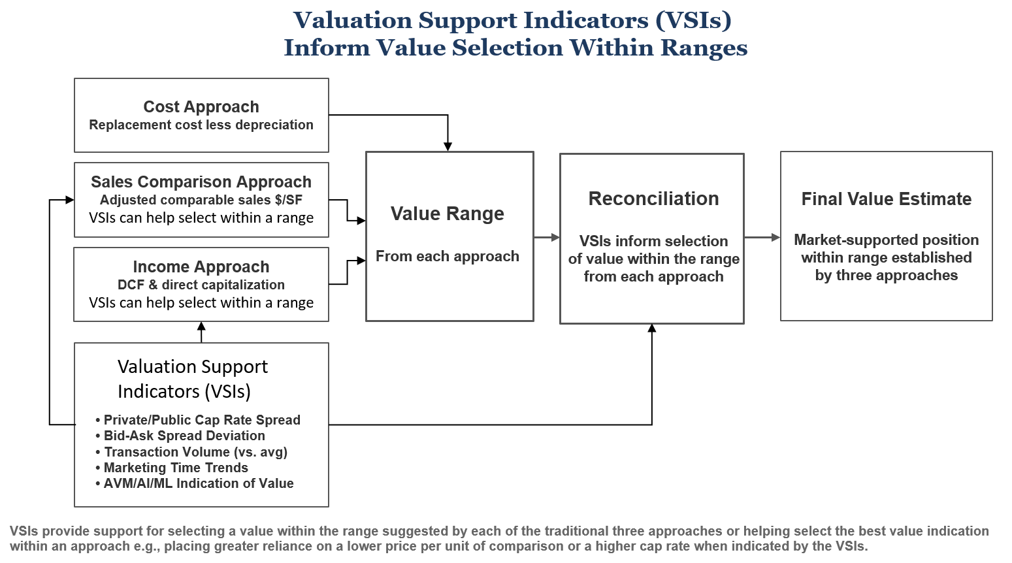

6.2 Marketing Time Indicator
As discussed, the definition of market value assumes that the property has been exposed to the market for a reasonable period prior to the valuation date. Under normal conditions, reasonable exposure times are well established, typically three to six months for institutional-quality properties. When market conditions extend required marketing periods significantly beyond these norms, this indicator supports selecting a value toward the lower end of the range suggested by the traditional approaches.
The indicator is assessed by comparing current average marketing times to historical averages for similar properties in the relevant market. When most properties require substantially longer to sell than they did under normal conditions, this extended timeframe indicates either that sellers must accept price concessions to achieve sales within typical periods, or that the traditional appraised value can only be realized through an unusually long marketing effort.
To use this indicator, the appraiser gathers data on current marketing times from listing services, broker reports, and transaction databases. If current marketing periods exceed historical norms by a significant margin, this supports selecting a value toward the lower end of the range—such as placing greater reliance on a lower price per unit of comparison. The strength of the signal corresponds to the degree of departure from normal marketing conditions—modest extensions provide modest support for lower-range values, while severely extended marketing periods provide stronger support.

6.3 Bid-Ask Spread Indicator
In normally functioning markets, the gap between seller asking prices and buyer offering prices remains relatively narrow, and transactions close within a predictable range. During stressed markets, this bid-ask spread often widens substantially as sellers anchor to prior values while buyers demand larger risk premiums (lower prices).
The indicator is assessed by examining current bid-ask spreads relative to historical norms. When spreads have widened significantly—from a typical range of five to eight percent to fifteen percent or more—this widening indicates fundamental disagreement between buyers and sellers about appropriate pricing. The transactions that do close under these conditions may represent special circumstances rather than typical market activity.
To use this indicator, the appraiser gathers bid-ask spread data from broker surveys, listing price versus sale price comparisons, and market participant interviews. When spreads are severely widened, this indicator supports selecting a value toward the lower end of the range suggested by the traditional approaches—reflecting the concession from asking price that would likely be required to attract a buyer and complete a transaction.

6.4 Transaction Volume Indicator
This indicator explicitly ties the strength of the signal to liquidity conditions. The methodology is to first establish a baseline transaction volume (e.g., trailing 5-year average quarterly volume by property type and market). Then calculate current volume as a percentage of baseline. When volume drops below a threshold (e.g., 60% of baseline), this indicator supports selecting a value toward the lower end of the range suggested by the traditional approaches. The strength of the signal is scaled to the severity of the volume decline, based on the ratio of the current quarter transaction volume to the baseline average volume.

6.5 AVM/AI/ML Divergence Indicator
As discussed in Section V, automated valuation models (AVMs), artificial intelligence (AI), and machine learning (ML) techniques offer increasingly sophisticated approaches to property valuation. Rather than viewing these as competing methodologies, they can be incorporated as a fifth VSI. When the value derived from a credible AVM or ML model diverges materially from the value range established by the three traditional approaches, this divergence may signal market conditions or property characteristics that warrant further analysis.
To use this indicator, the appraiser compares the value indication from a recognized AVM or ML model to the value range established by the traditional approaches. When the AVM/ML value is materially lower than the traditional appraisal range, this divergence may indicate that the model has captured market signals—such as shifts in investor sentiment, emerging comparable transactions, or broader economic indicators—that have not yet been fully reflected in the comparable sales, income projections, or cost estimates used in the traditional analysis. A downward adjustment, appropriately dampened to account for model limitations and the "black box" nature of some algorithms, may be warranted.
This indicator requires careful application. The appraiser must evaluate the credibility of the AVM or ML model, including its data sources, transparency, and track record. When used judiciously, the divergence between traditional and model-based values can serve as an additional market signal—not a replacement for professional judgment, but an VSI that informs value selection within the range and enhances the comprehensiveness of the valuation analysis.

6.6 Application Considerations
These five VSIs are designed to inform—not replace—the reconciliation of value indications from the three traditional approaches (cost, sales comparison, and income). The VSIs address related but distinct aspects of market dislocation and should be considered together when informing where within the range the appraiser should select a value. Because all five phenomena often occur simultaneously during market stress, the VSIs can be weighed to determine the overall direction and strength of their signal. When the weighted VSIs indicate market stress, they support selecting a value toward the lower end of the range suggested by each of the traditional approaches—such as placing greater reliance on a lower price per unit of comparison or a higher cap rate. They can also be part of the narrative in the reconciliation stop even if quantitative measures are not available for any or all of them. They could also be used to help select the value indication within an approach rather than what approach receives more emphasis.
When reporting values, appraisers should make it clear how the VSI was incorporated into the process. This transparency allows users to understand how use of the VSI provided market-based rationale for the appraiser's reconciliation judgment.

VII. Upholding Process Integrity and Professional Standards
Maintaining process integrity is paramount to ensuring unbiased, accurate, and reliable commercial real estate valuations, particularly given the inherent pressures and ethical considerations prevalent in the industry.

7.1. Mitigating Client Pressure and Undue Influence in Commercial Appraisals
Evidence from litigation and regulatory documents consistently reveals persistent attempts by "deal principals"—including clients, brokers, and lenders—to influence reported values in commercial appraisals. This pervasive nature of client pressure creates a systemic vulnerability that can compromise the appraiser's independent judgment. Academic research has identified clear pathways for such client pressure, particularly within commercial portfolios and during economic downturns. Patterns such as "contract-price clustering," where appraised values align suspiciously closely with the contract price, further suggest that appraisers may be "target-hitting" under pressure. This necessitates not only clear regulatory prohibitions but also a strong culture of ethical fortitude within the appraisal profession to resist "target-hitting" and safeguard the integrity of valuations.
Specific client pressure tactics and violations of appraiser independence are well-documented. These include direct requests for specific valuation outcomes, such as asking appraisers for an anticipated value range (e.g., a certain dollar per unit), a specific capitalization rate, or desired market rent and expense figures for a particular property.²⁰ Another common tactic involves sharing sensitive loan information, including targeted loan amounts, desired appraised values, Loan-to-Value (LTV) ratios, or Debt Coverage Ratios (DCR), with appraisers, which can subtly or overtly influence the valuation process. Furthermore, directing or requiring the appraiser to use particular sale, rent, or expense comparables in their analysis, even if the appraiser finds them inaccurate or unsupported, constitutes a direct violation of independence.
Pressure can also manifest through threats and incentives. Lenders and other stakeholders may exert influence through direct or indirect coercion, explicit or implicit threats to withhold future business, or by offering incentives or rewards for favorable appraisals.²¹ For example, withholding compensation from an appraiser because a property is not valued at a certain amount, or implying that future retention of services depends on the valuation amount, is considered unacceptable practice by regulatory bodies. Additionally, a bank's reliance on a borrower-ordered or borrower-provided appraisal is explicitly prohibited by agency regulations, as it introduces a direct conflict of interest that compromises the appraiser's impartiality.²²
Institutional investment managers typically use fair value accounting where they mark their properties in funds to market every quarter. The performance of their properties is often compared to benchmarks that reflect the performance of other investment managers who are also marking their properties to market. This creates a dilemma when markets are weak, and values are falling because those managers who react the quickest to the change in market conditions and mark their values down end up underperforming the benchmark, which includes the performance of managers who did not lower their values as quickly. Not wanting to be the first to write down the value of properties can cause the manager to seek out appraisers who might be less aggressive in lowering their property values.
Jim Costello wrote: “Objectivity in appraisals has been a problem for the business of real estate in the U.S. before. In decades past, there were fewer external appraisals conducted, with firms valuing their own assets. This approach created skewed incentives for managers to hide the fact that asset values were falling. If you tell clients that values are holding up despite market challenges, and if you keep clients at bay long enough, perhaps values recover, and LPs can exit the fund without taking losses.” He goes on to question: “How can asset owners ensure that the same perverse motivations do not re-enter the industry now or into the future? Do asset owners have the tools available to challenge or test the appraisal assumptions delivered to them? Looking at the disconnect between what appraisals and transaction-market prices would suggest for investment returns does provide some support to the notion that motivations have been skewed.”²³

7.2. Ethical Considerations
At the core of professional appraisal practice are fundamental ethical principles: impartiality, objectivity, independence, and freedom from personal beliefs or biases.²⁴ Appraisers are expected to exercise independent judgment in developing their value opinions.²⁵ However, beyond overt client pressure, unconscious biases pose significant ethical challenges to commercial appraisal integrity. These internal factors can lead to misrepresentations and inaccurate valuations, underscoring that a robust ethical framework and continuous self-awareness are as crucial as external regulations for ensuring objective and credible appraisals.
Appraisers might also be influenced without realizing it by information being held back from them by clients. In a weak market when there are few transactions, investment managers who have their portfolios valued every quarter by appraisers may be receiving bids for properties, but they don’t want to sell at the bid price. There is a wide bid-ask spread. But this is still relevant information that might impact the appraiser’s conclusion about the value.

7.3. Regulatory Frameworks and Industry Initiatives for Appraiser Independence and Transparency
The need for appraiser independence rules has been consistently highlighted by evidence from litigation and regulation. The Uniform Standards of Professional Appraisal Practice (USPAP) serves as the foundational national standard for real estate appraisal, explicitly requiring ethical behavior and unbiased practices from appraisers. Secondary market institutions like Freddie Mac, while not regulators in the traditional sense, effectively mandate that appraisers adhere to USPAP by requiring compliance as a condition of loan purchases, and have adopted Appraiser Independence Requirements (AIR) in direct response to concerns about undue influence on valuations.²¹

7.4. Appraiser Autonomy vs. Analytical Tools: The USPAP Challenge
While the integration of advanced analytical tools offers undeniable benefits to the appraisal profession, their use can create a perceived tension with established professional standards, particularly those outlined in the Uniform Standards of Professional Appraisal Practice (USPAP). Appraisers may feel constrained by USPAP's requirements when using "black box" technologies like AVMs and Machine Learning, leading to questions about the feasibility of fulfilling their professional obligations in a data-driven world.
USPAP Advisory Opinion 18 directly addresses the use of AVMs, emphasizing that an AVM's output is not a replacement for an appraisal but is instead a tool that must be evaluated by the appraiser for credibility before being used to develop a value opinion. This guidance places the burden of responsibility squarely on the appraiser to ensure the final valuation is credible and not misleading. USPAP requires appraisers to have a "basic understanding of how the AVM works" to determine if its use is appropriate for the assignment and if its output is credible. The appraiser must also disclose the use of any AVMs or AI algorithms, including a "brief description of the AVM's methods, assumptions, and level of allowed user intervention, to the extent possible".²⁶
This creates a significant challenge for appraisers, as it can be unrealistic for them to fully understand the inner workings of complex, proprietary AI models. The "black box" nature of many advanced algorithms means their precise decision-making process is often opaque, even to their creators. Appraisers are not expected to be data scientists, yet USPAP requires them to have sufficient understanding to assess the tool's credibility. The appraiser's core role is to exercise professional judgment to inform, not to dictate, the value opinion. The final value conclusion remains the appraiser's responsibility, and the use of these tools does not absolve them of the need to develop a credible appraisal using recognized methods. This highlights a central conflict: the need for transparency and professional accountability clashes with the inherent opaqueness of many advanced analytical models. It underscores the critical, and perhaps more challenging, role of the modern appraiser: to act as a knowledgeable interpreter and a final, autonomous arbiter of value, scrutinizing the outputs of all tools, traditional or technological, before reaching a conclusion.
While AVMs, and use of AI and machine learning might be a challenge for appraisers to incorporate into the appraisal process, the adjustments for public markets, marketing time, bid – ask spread and transaction volume should be consistent with USPAP. The Uniform Standards define market value assuming "reasonable exposure time." When bid-ask spreads indicate abnormal exposure times are required to achieve more realistic appraised values, an adjustment is conceptually appropriate. The adjustment could be framed as reflecting an extraordinary assumption about current market conditions when direct comparable evidence is stale. The methodology should be clearly disclosed, including data sources, calculation methods, and the rationale for adjustments. The framework also aligns well with Level 2 and Level 3 measurement requirements under fair value, where market participant assumptions must be applied when direct transaction evidence is limited. The adjustment explicitly incorporates observable market inputs (REIT pricing, volume data) to refine unobservable inputs (private market values).

VIII. Conclusion
The traditional commercial real estate appraisal framework, while historically robust, faces undeniable limitations in today's volatile and data-rich markets. The divergence between private and public market indications of value suggests the inadequacy of a singular valuation approach for diverse purposes, particularly during periods of economic distress or structural market shifts. The methodological constraints of the conventional cost, sales comparison, and income approaches—manifesting as challenges in data availability, subjectivity of adjustments, and forecasting volatility—further highlight the need for a more dynamic toolkit.
The integration of public market indicators, such as REIT pricing data and sentiment indices, offers a critical pathway to enhance appraisal timeliness and provide leading market signals that traditional lagging data cannot. Simultaneously, the adoption of advanced analytical tools, including AVMs and machine learning, presents immense opportunities for improved accuracy, efficiency, objectivity, and scalability in commercial property valuation. However, the "black box" nature of some ML models and persistent data quality hurdles necessitate careful implementation and the continued development of explainable AI solutions.
A Valuation Support Indicator (VSI) framework—one that preserves the three traditional approaches while providing market-based rationale for value selection within the ranges they establish—offers the most promising path forward. This framework judiciously blends the irreplaceable professional judgment of experienced appraisers with real-time market indicators and modern analytics, without abandoning the foundational cost, sales comparison, and income methods. Five VSIs have been suggested to inform the reconciliation process: 1) public-private market pricing spread, 2) marketing time trends, 3) bid-ask spread deviation, 4) transaction volume, and 5) AVM/AI/ML divergence.
The VSIs could be used to justify putting more weight on the result of one of the three traditional approaches to estimating value or used to help select the value indication within an approach—such as placing greater reliance on a lower price per unit of comparison or a higher cap rate when indicated by the VSIs. This framework should enhance the accuracy, timeliness, and transparency of commercial real estate valuations, making them more relevant and reliable for diverse stakeholders.
We must keep in mind that properties are unique and whatever models and databases are relied on must allow appraisers to capture the unique characteristics that might cause a property value to differ from what the model might otherwise predict. There is still a need for an experienced appraiser’s judgment. At the same time, incorporating additional models and sources of data that go beyond those that drive the traditional approaches to value can help produce value estimates that better reflect true market conditions. Developing ways for incorporating additional approaches into the appraisal process is an important area for future research.
Of course there will be challenges. The more we rely on AI and machine learning the less we might know about exactly how the value was derived, including what data was actually used. This could especially be a problem if the appraisal is used in court proceedings. Some judges don’t even allow the use of discounted cash flow analysis since it involves assumptions and forecasting. Perhaps the answer is to be able to show the reliability of a particular machine learning / AI model that has been developed along with a better understanding of the relationship between public and private market pricing. More research needs to be done on exactly how the additional approaches suggested in this article such as consensus surveys, machine learning, public market information, etc. should be incorporated into the appraisal process.
In conclusion, the three traditional approaches cannot be replaced. But we can inform the reconciliation of their value indications with Valuation Support Indicators that may not have been available in the past—providing market-based rationale for selecting a value within the range suggested by each approach when conditions such as low transactions, extended marketing times, and wide bid-ask spreads indicate market stress. This is especially important when there are significant movements in the market and it should help restore more confidence in the appraisal process.
IX. References

- “A Valuation Lag to significant to Ignore.” Prologis Research, Feb 2024
- Ed Pierzak, “Wearing Blinders: Some CRE Appraisals Continue to Ignore Capital Market Realities.” NAREIT April 9, 2025
- Quick Take: Informational. NCREIF NPI vs. Green Street CPPI ® October 29, 2005.
- Fair Market Value vs. Investment Value: What's the Difference? - Investopedia, accessed August 11, 2025, https://www.investopedia.com/articles/investing/110315/investment-value-vs-fair-market-value-how-they-differ.asp
- Sales Comparison Approach Deep Dive: Property Adjustments ..., accessed August 11, 2025, https://www.mccoyvaluation.com/sales-comparison-approach-deep-dive-property-adjustments/
- Appraising Change | The CCIM Institute, accessed August 11, 2025, https://www.ccim.com/insights/commercial-connections/fall-2022/appraising-change
- 2025 Commercial Real Estate Midyear Outlook - J.P. Morgan, accessed August 11, 2025, https://www.jpmorgan.com/insights/real-estate/commercial-real-estate/midyear-commercial-real-estate-outlook
- How the Cost Approach in Real Estate Reveals Hidden Property Value - reAlpha, accessed August 11, 2025, https://www.realpha.com/blog/cost-approach-in-property-valuation
- CPPI | Commercial Property Price Index - Green Street, accessed August 11, 2025, https://www.greenstreet.com/insights/CPPI
- The NAIOP CRE Sentiment Index | NAIOP | Commercial Real Estate Development Association, accessed August 11, 2025, https://www.naiop.org/research-and-publications/sentiment-index/
- What is an Automated Valuation Model (AVM)? Everything you need ..., accessed August 11, 2025, https://mortgagetech.ice.com/blog/what-is-an-automated-valuation-model-avm-everything-you-need-to-know
- How Automated Valuation Models (AVMs) Are Revolutionizing Property Investment Strategies | The Warren Group, accessed August 11, 2025, https://www.thewarrengroup.com/blog/how-automated-valuation-models-avms-are-revolutionizing-property-investment-strategies/
- Unlocking the Power of Predictive Analytics in Real Estate, accessed August 11, 2025, https://www.numberanalytics.com/blog/power-real-estate-predictive-analytics
- Introduction To Machine Learning In Commercial Real Estate - Part ..., accessed August 11, 2025, https://www.altusgroup.com/insights/introduction-to-machine-learning-in-commercial-real-estate-part-1/
- Using Machine Learning and Big Data to Predict Real Estate Returns, accessed August 11, 2025, https://warrington.ufl.edu/due-diligence/2025/03/19/machine-learning-big-data-predict-real-estate-returns/
- AI Explainability Explained: When the Black Box Matters and When It Doesn't, accessed August 11, 2025, https://www.debevoise.com/insights/publications/2025/07/ai-explainability-explained-when-the-black-box
- Machine Learning Algorithms and Explainable Artificial Intelligence for Property Valuation, accessed August 11, 2025, https://www.mdpi.com/2813-8090/2/3/12
- An LLM-Generated Explainable Property Valuation System with Neighbor Imputation - arXiv, accessed August 11, 2025, https://arxiv.org/html/2503.12344v1
- Revisiting Automated Valuation Model Disparities in Majority-Black Neighborhoods - Urban Institute, accessed August 11, 2025, https://www.urban.org/sites/default/files/2022-05/Revisiting%20Automated%20Valuation%20Model%20Disparities%20in%20Majority-Black%20Neighborhoods.pdf
- Appraiser Independence Requirements FAQs - Freddie Mac, accessed August 11, 2025, https://mf.freddiemac.com/docs/mf_air_faqs.pdf
- Appraiser Independence: A Comprehensive Guide - Number Analytics, accessed August 11, 2025, https://www.numberanalytics.com/blog/ultimate-guide-appraiser-independence-property-valuation
- Commercial Real Estate Lending 2.0 - Office of the Comptroller of ..., accessed August 11, 2025, https://www.occ.gov/publications-and-resources/publications/comptrollers-handbook/files/commercial-real-estate-lending/pub-ch-commercial-real-estate.pdf
- Jim Costello, The Risks of Appraisal Uncertainties in Private Real Estate, December 13, 2024, MSCI working paper.
- Professional Practice and Law | Appraisal Institute, accessed August 11, 2025, https://www.appraisalinstitute.org/getmedia/26c6ce46-022f-404c-aa4b-8c2e5af64d86/ARE-15-appendix-A-linked

- Experience Credit Candidate Guidebook | Appraisal Institute, accessed August 11, 2025, https://www.appraisalinstitute.org/getmedia/3dc7c405-f6a0-413b-a18f-a32e7b5af478/exp-guidebook
- USPAP - The Appraisal Foundation, accessed August 11, 2025, https://appraisalfoundation.org/products/uspap
- Geltner, D., 1991. Smoothing in appraisal-based returns. The Journal of Real Estate Finance and Economics 4, 327–345.

This work was originally supported by the UF Bergstrom Center
National Council of Real Estate Investment Fiduciaries (NCREIF) collects quarterly data on the performance of properties held by institutional real estate investors that is used to produce the NCREIF Price Index (NPI) as well as other metrics on the performance of properties such as cap rates. See www.ncreif.org.

